Error Handling in ASP.Net MVC6

When Error Occurs you can handle them in a variety ways .

1. Developer Exception Page

* To Configure an app to display a page that show detailed information about exceptions.
* You need Microsoft.AspNetCore.Diagnostics
* To See this page run it in developer environment.

Demo : Display Developer Exception Page

1. Create Empty ASP.Net Core Web application name it ErrorHandling Demo
2. Add a App controller with Index, Contact and About Method. Add dummy view for it.
3. Add Exception code in contact method.

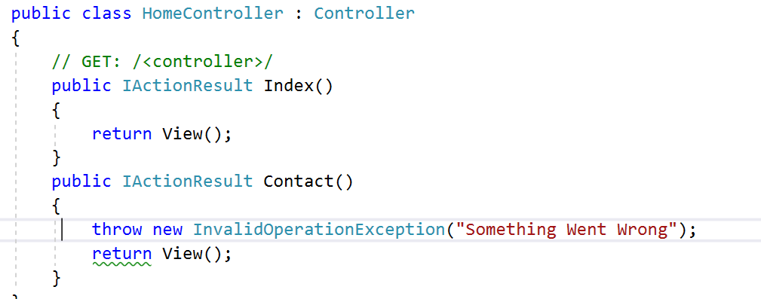

1. We want to display developer error page. So we have to configure it in Startup.cs

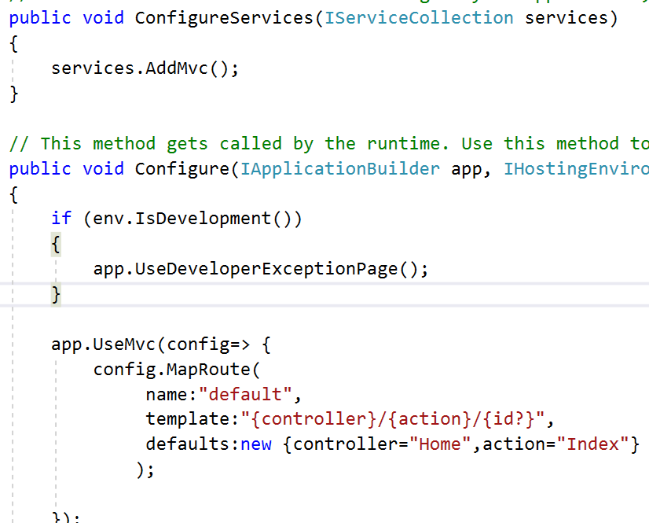

1. See the output.

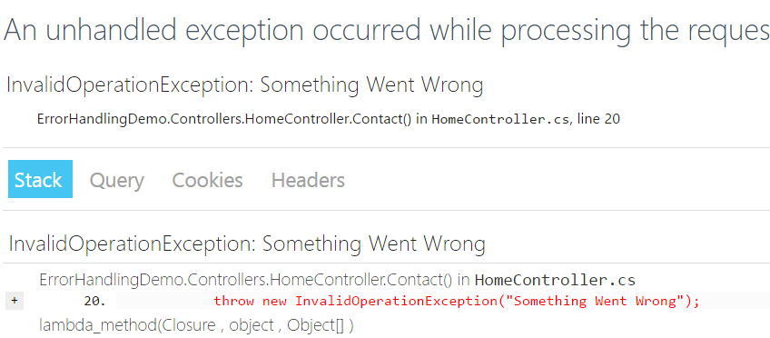

1. Configuring Custom Exception Handling Page

* You can configure handler page when the app is not running in the development environment.

Demo : How to Redirect to a Some error page whenever error occurs in a Production env.

1. Add ErrorsController and add View for Index Method.

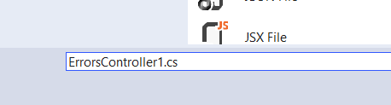

1. Add A view for ErrorController , index method and add some dummy html code.

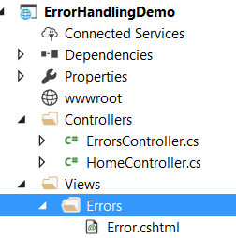

1. Add a code in ErrorController

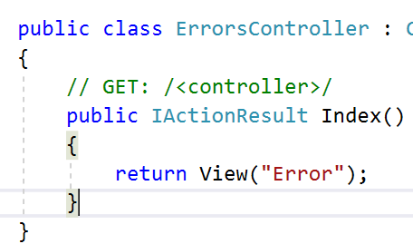

1. Now configure Startup class using USeExceptionHandler middleware so that the custom page will be shown whenever things goes wrong.

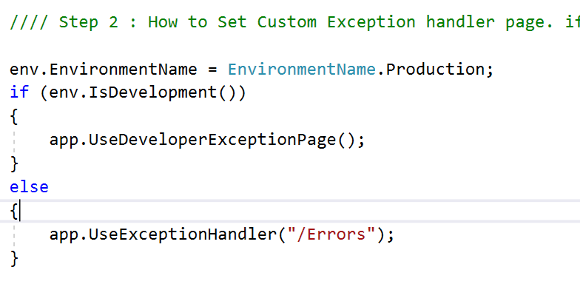

1. When you go to Home/Contact you will get error page.

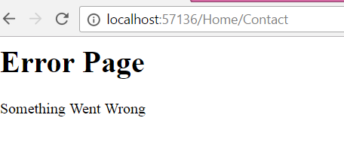

1. Above 2 methods checks code errors but when we have to handle 404 or 500 error we have to do something else
2. Add a middleware in startup.cs

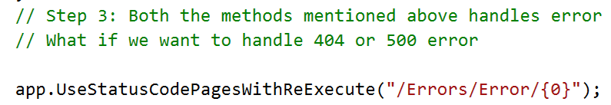

1. Add a method in Error Controller

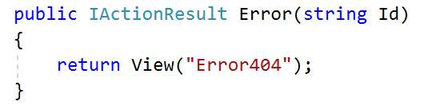

1. Create Error404.cshtml



1. Output.

